To: Dr. Halil Berberoglu

From: Collin Murphy, Rachel Purvis, Andrew Sheu, Bryan Stockberger, Zach Straw

Date: 5/6/2011

Subject: Semester Project Phase Two

Cogeneration Introduction

Cogeneration is the ability to increase the efficiency of any power cycle by using the same fuel source to simultaneously produce electricity and heat. This boost in efficiency can prove itself to be a worthwhile investment opportunity, according to a system’s thermo-economic structure. Cogeneration is a process whereby waste heat energy is recycled to provide heat input to another portion of a power cycle. In a Brayton cycle, heat extracted from the turbine has the capacity to heat the working fluid in another portion of the cycle in an effort to increase thermal efficiency. Modern day power-plants operating on a Brayton cycle require that the turbine stage extract as much work as possible out of the thermal fluid at an elevated pressure, expanding the fluid to a lower pressure (Schmidt et. al, 2006). By optimizing the amount of heat extracted at different stages of the power cycle, the realization is made that power systems increase efficiency and minimize exergy destruction by applying a cogeneration system.

Overall system efficiency is affected by cogeneration in that the system recycles some of the thermal energy it produces from consuming fuel. By using the excess energy exhausted from the turbine in a Brayton Cycle to power another process in the cycle, the operating costs of power the system decrease and thermal pollution is reduced. Questions that arise when implementing a cogeneration system are whether to maximize the thermal efficiency of the system, which focuses on maintaining a specific temperature at certain points in the system. Compare the former to a fiscally conservative system that focuses on minimizing costs and regulates the temperature of the waste steam to a range that is more profitable. Stable ranges exist between operating cost and thermal efficiency for a cycle, each system is tailored to suit the energy needs of the region it serves (Meador, 1981).

There are different scenarios that cogeneration is capable of providing an increase in efficiency. These processes include those with no cogeneration, thermal-match cogeneration, electrical-match cogeneration, or maximum cogeneration. “No cogeneration” exists when thermal energy is generated entirely for use by the cycle, meaning that all electrical power is purchased from a utility company and none is generated from heat. “Thermal-match” cogeneration produces thermal energy at temperatures and pressures much higher than that required for the power cycle processes. Electric power is generated by the steam at elevated conditions, afterward recovering the steam for use in generating power. The cogeneration system is sized so that thermal energy generated from the system is just enough to meet the demands of the cycle. In “electrical-match” cogeneration, thermal energy is again produced at elevated temperatures and pressures, similar to the thermally matched case. Electrical power is produced first by the steam, and the recovered steam is then used to power the cycle. The difference in this cogenerative effort is that now the cogeneration system is sized to meet electrical power demands of the cycle. Finally, “maximum cogeneration” exists when thermal energy is produced in excess of the cycle in order to maximize certain output parameters. Once electrical power demand is met from producing excess steam, the remainder of steam is dumped to the heat sink, usually the atmosphere. This cogeneration system is sized for maximum economic gain, such as maximum cash flow, or minimal fuel investment (Hu, 1985). These scenarios are put into practice by incorporating new technology to boost performance in an operational power cycle.

State of the art cogeneration systems improve basic power systems by adding components that redistribute the thermal energy within the system. Cogenerative systems implemented into existing power-plants take into account various system characteristics. Some generalized parameters include fuel chargeable to electric power, overall system efficiency, electricity per steam flow, minimum process steam required, emission problems, capital costs, gross payback period, specific heat rate, unit size and operational lifetime (Hu, 1985). These standards can be critiqued based on a cost/benefit analysis as well as technical inspection with emphasis placed on criteria pertinent to different levels of cogeneration. State of the art technology is influenced by the need for supplying consumers with energy at the cheapest cost.

There are many factors that contribute to defining the current state of the art cogeneration plant. These deciding elements include political stability, social growth, and economic development. Political stability of a country can affect the current technologies by implementing different regulatory policies. Interpretation of these policies can in turn determine how manufacturers and corporations carry out certain projects. Industries will be forced to follow rules pertaining to many areas, including those for manufacturing and building costs, energy regulations, and environmental laws. The increasing of advancement of society’s can also have a major influence on the designs and definitions of the current state of the art. As more knowledge about different trends in cogeneration is attained, many companies will begin to formulate new ways to implement projects that will utilize the advantages of these concepts, creating technologies that will influence and change the current state of the art. The economic conditions of a society also have a significant influence in what the state of the art of cogeneration plants are decided to be. The economic development at a certain time can determine the costs of certain materials by either increasing or decreasing their prices. This factor will influence the purchase of these materials that could be used to manufacture the different components of the plant (Limaye, 1987).

A state of the art cogeneration plant is one that employs the combined cycle. The simple arrangement of a combined cycle is comprised of gas turbines and steam turbines that recover heat to produce steam for a steam turbine generator. The typical cycle obtains output heat from an open gas circuit and inputs that energy into a heat recovery steam generator that will output the energy back into a combustor or boiler to be reused in the cycle. For the Westinghouse Model 251B Combustion Turbine System, the heat recovery steam generator uses the output energy to help adjust the temperatures of the water supply across the university campus, showing the benefit of the utilization of the cogeneration process in the power cycle. The Westinghouse Model 251B Combustion Turbine System is state of the art technology comprised of multiple components that are used to help generate heating and electrical power to the campus of the University of Texas at Austin. The system is made up of a starting package, an inlet air system, inlet fuel systems, air filters, a combustion turbine assembly, and multiple generators. The starting package uses a general motor to help start the process where the inlet air system and the air filters help to intake and purify air that will be used to drive the combustion turbine system. The fuel system inputs the desired fuel into the combustion turbine assembly, which is composed of a compressor, a combustor, and a turbine, to help generate power for desired processes as well as exhaust gases. The exhaust gases are then relayed either into the atmosphere or through heat exchanging generators. These generators include an open-air cooled generator or a water-cooled generator. These generators use the exhaust gases to heat up other exchanging fluids to help provide the plant more input reactants to increase power output. The thermal performance of this technology based on the use of natural gas fuels shows that approximately 48000kW of power can be generated with the heat exchanging components helping to utilize approximately 11,165kJ/kWh of lost energy, proving again the great impact of cogeneration (Westinghouse, et al).

In addition to heat exchanging generators, multiple pressure boilers, extraction steam turbines, and condensers can be used to better the performance of processes through cogeneration and the combined cycle. A combined cycle can obtain up to 80% utilization of fuel input and an efficiency that varies between 50 to 58% compared to the other cycles that have less than 50% efficiency. Other advantages of the combined cycle are low gas emissions, low capital costs, small space requirements, and easy implementation of machinery (Poullikkas, 2004).

The combined cycle can be applied to many applications, which include those for heating and electricity. In plants that employ the current state of the art to provide heating to inhabited areas, maximum steam outputs are necessary for the fuel inputs that are used. This consideration results in plants having additional boilers. Efficiency of the plant can be increased by inserting extra units. Usually the efficiency required for this heating application requires high energy efficiency and provides the highest economic value (Hu, 1985). For electricity production, condensers are inserted to provide flexibility in the electrical output. The configuration of these types of plants is similar to that of the heating applications but is smaller in size and limited by the consumer demand and rate costs. Thus, the combined cycle will be used to maximize the heat the fuel ration to meet the demands (Hu, 1985).

As of now, the implementation of this current state of the art has provided more benefits than other cycles that have been discovered. Although these benefits are useful for the current societal needs, there are still flaws in efficiency and output production. As cogeneration finds application in power plants across the globe, new technology helps overcome energy problems. The goal to maximize energy production while minimizing fuel consumption drives research to find new cogeneration methods.

By implementing cogeneration, fuel is conserved by being recycled back through the system instead of released to the atmosphere. The recycling process also saves energy in areas other than the power cycle system. Cogeneration also outputs a much more dependable amount of energy to the public. Cogeneration has proven to be much more efficient than the conventional fossil steam plant. Approximately 75% of the heat is utilized for power and heat for a cogeneration cycle with only about 25% exhaust steam. But in a fossil steam plant, only 35% of the energy from fuel is obtained as power; the exhaust gases from the condenser and boiler that end up being waste are 48% and 15%, respectively (Boyce, 2002). Not only do cogeneration cycles output more dependable power, but is also a viable means of energy if any kind of emergency such as natural disasters affected a power plant.

By using cogeneration, not only is energy recycled but sources that are under constant worry of depletion, such as fossil fuels and petroleum, are also conserved. Not only are these valuable resources preserved, but the energy required to transport and produce these resources are also conserved. Since waste energy is recycled in a cogeneration power cycle, the vapor waste that was expelled from the system reduces harm to the environment. Many power plants are under constant scrutiny from environmentalist groups about how waste adversely affects animal habitats and causes irreparable damage. Cogeneration power plant cycles help to curb unnecessary waste by utilizing it to actually improve system performance, which coincidentally helps the environment.

Cogeneration saves energy that was once thought to be waste. The caveat to cogeneration is whether to maximize power of the system or to make the system economically feasible. Through the examination of cogeneration, the Westinghouse 251B Combustion Turbine system at the University of Texas at Austin has helped to cover basis on both aspects and has contributed to fulfilling society’s goals of maximum production for minimal consumption.

Introduction

The final phase of the project extends from the analysis of the Westinghouse Model 251B Combustion Turbine System, which includes incoming air with various moisture levels entering the system through an evaporative cooler. Adding this to our system will simulate realistic humidity of the air, while including a pressure drop across the guide vanes leading to the evaporative cooler will provide a more realistic system that includes losses due to pressure. Also included is combustion modeling and analysis of the fuel entering the combustor. The analysis should produce reasonably accurate values that are comparable to the accuracy of the manufacturer’s specifications. After checking the accuracy of the simulation, a number of case studies will be run to investigate how the performance of the system varies according to changes in weather, pressure losses and effects of the evaporative cooler. Finally, an exergy analysis will be conducted to identify system inefficiencies that aren’t realized with the First and Second Laws of Thermodynamics. Finally, comments will be made to improve the efficiency of the W251B.

Procedure

In order to analyze the performance parameters of the updated system, the MATLAB code is restructured to include new assumptions. These assumptions expand on the idea that the cycle is an air-standard Brayton Cycle with an incoming volumetric flow-rate; the air flowing through the system is a temperature-dependent ideal gas with a reference temperature of 25⁰C and a reference pressure of 1 atmosphere. The air modeled in the system is pure with a composition of 21% O2 and 79% N2, and will include relative humidity values. Humidity control occurs across an evaporative cooler, which is modeled without a pressure drop. Combustion will be modeled with stoichiometric coefficients that represent the molar balance of reactants and products inside the combustion chamber. The fuel enters the combustion chamber at 59˚F, and will modeled as a natural gas mixture with a lower heating value of 20,960 . Nitrogen will be considered an inert species in the model of combustion. The idea of a dead state will be introduced, for the purpose of conducting an exergy analysis on the system, with Temperature T0= 298K, Pressure P0= 1 atm. This “dead state” will prove to be useful in the analysis of the exhaust gases leaving the turbine.

After taking into account the necessary assumptions, we can proceed to find the humidity ratio and mass flow-rate of dry air and water vapor, values that define the initial state (Equations 17 and 18). Across the guide vanes and filter, a pressure drop of 4 inches H2O occurs, resulting in a consequent temperature drop. From state 1 to 2, an energy balance was performed on the evaporative cooler. Keeping in mind that the relative humidity at state 2 is known to be 100% after leaving the evaporative cooler, the humidity ratio is found for an initial guessed temperature (Equation 20). Guessing a value for T2 based on an upper bound for T1 and a lower bound of 0°C, the bisection method is applied to find T2 based on the energy balance. In between state 1 to 2, water is added to the evaporative cooler which changes the molar composition of the air. This is taken into account in the MATLAB program by adding the moles of water per moles of air to the array and dividing by the total sum of the array. Using the value iterated for T2, the enthalpy and internal energy can be found from the property calculator. By using the spline fit function, values for hliquid and hvapor are calculated for the energy balance. The spline fit makes a curve fit between each property value instead of linearly interpolating, increasing the accuracy of the model.

Analysis of the compressor across states 2 and 3 requires that the model be updated to include the varying moisture content of the air. Given the compressor pressure ratio, rp, assuming constant entropy for compressor gives entropy at state three. MATLAB then calculates isentropic enthalpy for state three. Given the compressor efficiency, the actual enthalpy at state three is calculated (Equation 5). T3A is then found using MATLAB.

The approach to find the mass flow rate of the fuel entering the combustor involves an iterative approach, whereby choosing values of the mass flow and incrementing them until the known power output of the system is reached. From here, the lower heating value is multiplied by this flow rate to obtain the heat addition rate to the combustor. From states 3 to 4, a chemical stoichiometric balance gives the coefficients of the products which are plugged back into the array representing the molar composition of the combustion species. Then an energy balance was performed on the combustor using the found stoichiometric coefficients, as well as the lower heating value for the various molar species (Equation 21). Enthalpy is found for the wet air incoming, the mass flow rate of wet air times the enthalpy from state three gives us the energy for incoming air. Mass flow rate of fuel times the lower heating value gives the incoming energy for the fuel. Summing these two energies gives total heat which is divided by total flow producing heat energy per mass which is the enthalpy at state four (Equation 16).

From state 4 to 5, the pressure at state five is given as 1atm since the gases are exhausted to the atmosphere. Assume constant entropy, so entropy at state four will equal entropy at state five. Given the pressure and entropy, MATLAB can calculate the isentropic enthalpy at state five. From turbine efficiency and isentropic enthalpy, the actual enthalpy at state five can be determined (Equation 6). Then using MATLAB, the temperature at state five is calculated from the actual enthalpy value at state five.

After finding pertinent enthalpy values, the compressor and turbine work outputs could be calculated (Equations 7 and 8). Net mechanical work output could then be found (Equation 14), and this value multiplied by the generator efficiency would yield the net electrical work output (Equation 9). The heat rate was determined using the given electrical heat input (Equation 4) and the net electrical work output (Equation 10). It is important that the unit for the heat rate is equivalent to. Lastly, the specific fuel consumption was evaluated by dividing the fuel flow rate by the net mechanical power input to the system (Equation 15).

Given the dead state temperature and pressure, a steady state flow exergy balance was conducted on the turbine to find the exergy of the exhaust gases. This type of analysis is different from an energy balance, and provides insight into the useful work of the working fluid. This analysis shows the amount of energy left in the thermal fluid that can be rerouted to the system to improve the overall thermal efficiency. Finding the enthalpy, entropy, and volume of the exiting gas from the turbine is plugged into the exergy equation using enthalpy, volume and entropy values at the dead state (Equation 24).

Modeling and Analysis

Below is a flow chart showing the general methodology used to find unknown variables at each state.

Results and Discussion

**Output performance parameters**

It was observed that as the percent load increases, the thermal efficiency increases as well (Figure 12). This trend is valid because Equation 11 shows that as the net power output increases, so too does the thermal efficiency. However, as the percent load approaches its maximum performance, the efficiency increases at a smaller rate and eventually reaches a maximum. The fuel mass flow rate can be observed to grow linearly with percent load (Figure 13). This suggests that increasing the load of the system will directly increase the fuel flow demand. Specific Fuel Consumption decreases sharply with an increase in percent load from 20%-30% maximum power, and then slowly declines as the percent load increases to its maximum (Figure 14). Therefore, running the system above 30% load is preferred to minimize the amount of fuel consumed. The heat rate follows the same trend as specific fuel consumption when plotted against percent load (Figure 15). Thus, a lower heat rate will produce a more efficient system and a higher net work output. By increasing the percent load, the firing temperature was observed to increase as well. (Figure 16 - 17). This suggests that for more power output, a higher inlet temperature to the turbine is required. Temperature increased and pressure remained constant with increasing fuel flow at each major thermodynamic station (Tables 6-7).

**Case Study 1: Base case analysis of W251B for ISO standard conditions**

The computed and quoted net powers both have a value of 48 MW, giving a 0% error. However, for the rest of values, there was an error associated with the difference between our computed performance and the manufacturer’s quoted performance. For our base case scenario, we took the incoming natural gas to the combustor to have a composition by volume of 96.1% CH4, 2.5% C2H6, 0.2% C3H8, 0.8% CO2, and 0.4% N2. In the Westinghouse 251B manual, a different composition for natural gas could have been used, affecting the net electrical work of the system, and thus the heat rate. Also, the difference in the exhaust temperature and fuel flow values was off by an error of 12.691% and 12.575% respectively (Table 1). The fuel flow rate affects the stoichiometric balance equation across the combustor, which in turn affects the exhaust temperature leaving the turbine.

**Case Study 2: Effect of inlet and exhaust pressure losses:**

As the inlet pressure drop increases, the net power output of the system decreases at an approximately linear rate (Figure 6). This trend shows that in order to maximize the efficiency and work output performance on the Westinghouse 251B system, low pressure drops need to be maintained at the inlet. Likewise, the net power of the system decreases linearly with increasing pressure drop of water at the exhaust (Figure 7). Thus, the power output does not depend on whether the pressure drop occurs at the inlet or exhaust. At the exhaust, the pressure drop has no effect on the exhaust flow (Figure 11). Also, the exhaust flow remains constant regardless of the pressure drop of H2O at the exhaust (Figure 11). Therefore it can be inferred that exhaust flow and an inlet or exit pressure drop are independent of one another. It can be observed that heat rate increases linearly with an increase in the pressure drop at the inlet (Figure 8). Heat rate is linear with an increase in pressure drop at the exhaust (Figure 9). Compared to the Westinghouse correction factor plots, all of our values except for the exhaust flow associated with an inlet pressure drop adhere to the same trend. As heat rate increases, power decreases which as expressed in Equation 10. The discrepancy between our model’s exhaust flow due to an inlet pressure drop with the Westinghouse values is attributed to the fact that in our MATLAB program we assumed a constant fuel and air flow rate, when in reality an exhaust flow decrease would result from a pressure drop (Figure 10).

**Case Study 3: Part load and hot day Performance:**

As the exhaust temperature increases, the net power output increases in a linear fashion (Figure 22). With ambient air at 95°F, the system outputs a higher net work output than ambient air at 100°F. Therefore the cooler the ambient air is, the more efficient the Westinghouse 251B system is. Similarly, the net power increased at a linear rate with an increase in the firing temperature entering the turbine (Figure 21). At lower ambient temperatures, the system still outputs a higher net work with increasing firing temperatures. However, in reality, as the inlet temperature increases the net power output should decreases because of the density change of the air entering the system. Thus, as the density increases, less mass flow enters the system. This relationship is counterintuitive because the MATLAB program assumes constant mass flow rate of the air. The volumetric flow rate remains constant, but changing the density of the air changes the mass flow rate, resulting in lower power outputs for warmer, less dense air. The opposite is true for cooling the air, increasing the density, an idea that is utilized by adding an intercooler to the system to increase the density of the incoming air. Moving on from that, the heat rate decreases as the fuel flow load increases (Figure 23). This is as expected since a higher load results in a higher efficiency, thus decreasing the heat rate of the system. The exhaust temperature, exhaust flow, and fuel flow all follow that same trend as that found in the Westinghouse correction factor graphs (Figure 22). Furthermore, in reality higher temperatures would result in a higher heat rate. However, the MATLAB code produced the opposite relationship because of the constant mass flow assumption.

**Case Study 4: Effect of evaporative cooler:**

When the evaporative cooler is on, the power output is higher for the system than when the evaporative cool is off (Figure 18). The net power increases with increasing relative humidity. As the relative humidity approaches 100%, the net power output approaches the same value. Heat rate, on the other hand, decreases with increasing relative humidity; the heat rate with the evaporative cooler on is less than the value when the evaporative cooler is off (Figure 19). The two cases approach the same value as the relative humidity approaches one. This makes sense since the outlet of the evaporative was assumed to be 100%, so the difference between the inlet and exit relative humidity decreases and so does the difference between the systems output values. As the relative humidity increases, the evaporative water loss for the cooler-on case decreases at an almost linear rate (Figure 20). Therefore, in extremely humid conditions the evaporative cooler is not needed because it will not affect the output of the system significantly. The evaporative cooler would perform optimally in a hot environment with low humidity.

**Case Study 5: Exergy of the exhaust gases:**

Running the MATLAB code for the base case scenario at full load, it was determined that 31.7MW of energy was released to the environment. The total mechanical work output of the system operating at peak performance was 48MW, meaning that 66.04% of the net electric power output is lost to the environment instead of contributing positively to the system. Coupling a co-generation system with the W251B system would reroute some, if not all, of the lost energy back into the Westinghouse Model 251B Combustion Turbine System, increasing its overall efficiency and causing the system to output more useful work. This would also lower the system’s effect on the environment by reducing the amount of emissions released to the atmosphere. The initial cost of the cogeneration system will depend on what exact system will be added to the Westinghouse system. This cost, compared to the increase in efficiency of the overall system, will determine whether or not the addition of the cogeneration system can be justified. From our research described above, we believe that adding a cogeneration system would be justified and recommended.

Conclusion

This project has taught us how to use MATLAB to simulate the Westinghouse Model 251B Combustion Turbine system. We evaluated the effect that various parameters, including inlet and output pressure drops, ambient temperature, and an evaporative cooler, had on various thermodynamic properties, and how these properties altered the performance of the system as a whole. These values allowed us to see what parameters resulted in the most efficient system possible given the inputs. Also, through an exergy analysis we determined that cogenerative components coupled with the W251B system will improve the overall performance. Overall, we have expanded our knowledge of thermodynamic principles in order to model a real world scenario. By applying the skill set learned from this class, coupled with technical ability, we replicated a model of a real world working system, taking into account minor assumptions to simplify the model. We found that our model was able to reproduce values similar to the specifications of the manufacturer, a skill that proves itself valuable upon entering the workforce. Through this analysis of the W251B system, we were able to solve an -open-ended problem where information was not readily available and produce solutions that were counterintuitive.

References

Boyce, Dr. Meherwan P., P.E. *Handbook for Cogeneration and Combined Cycle Power*   
     *Plants*. New York: ASME Press, 2002. N. pag. Print.

Hu, S. David, Ph.D. *Cogeneration*. Reston, VA: Reston Publishing Company, Inc.,   
     1985. N. pag. Print.

Meador, Roy. *Cogeneration and District Heating: An energy-efficiency*   
     *partnership*. Ann Arbor, Michigan: Ann Arbor Science Publishers, Inc.,   
     1981. N. pag. Print.

Poullikkas, Andreas. "An overview of current and future sustainable gas turbine   
     technologies." *Renewable and Sustainable Energy Reviews* 9 (May 2004):   
     409-443. *Academic Search Complete*. Web. 4 May 2011.

Schmidt, Philip, et al. *Thermodynamics: An Integrated Learning System*. Hoboken,   
     NJ: John Wiley & Sons, 2006. N. pag. Print.

Westinghouse. *251B11/12 Econopac Application Handbook*. N.p.: n.p., n.d. Print.

Property Calculator

*Problem description and objectives*

The objective of the Property Calculator is to create a MATLAB program that will calculate thermodynamic properties for an ideal gas mixture that has differing molar compositions of gases. The thermodynamic properties of each constituent gas needed are molecular mass (M), specific gas constant (R), specific heats (cv and cp), ratio of specific heats (k), internal energy (u), enthalpy (h), and entropy (s). These properties are calculated based on the user input for molar composition, pressure, and temperature. The MATLAB program will take these user inputs and calculate properties for each constituent gas. Upon finding properties of the gases, the MATLAB program will validate and apply these properties to an actual ideal gas mixture problem. This property calculator will be able to efficiently calculate properties to achieve accurate power ratings for a turbine.

*Procedure*

Firstly, the MATLAB program asks for the temperature[°C], pressure [kPa], and molar compositions for the gases He, Ar, O2, N2, H2O, and CO2.

Molecular mass values were then taken from Table 2 in Schmidt’s *Thermodynamics* for each gas, and then summed together to determine Mmix (Equation 2). The reason for this molar mix calculation is to get the mass fraction (Equation 25) of each gas. The mass fraction was then used to find other mass based thermodynamic properties: specific heat, enthalpy, internal energy, and entropy. These properties were calculated by matrix algebra in the MATLAB program.

Next, specific heats were calculated for each gas. The polynomial expression for cp bar can be used for O2, N2, H2O, and CO2. This is represented in the MATLAB code by a coefficient matrix for the a, b, c, and d values of Equation 3. This coefficient matrix is multiplied by a temperature array producing cp bar. This cp bar value is divided by molecular mass to get cp for each gas. The only gases that did not use this expression were Ar and He because they were not included in Table 3s in *Thermodynamics* by Schmidt, Ezekoye, Howell, and Baker. Since both Ar and He are monatomic gases, Equation 27 was used instead to calculate cp. The R-values were taken from Table 2 in Schmidt’s *Thermodynamics* for each respective gas.

In order to calculate the entropy change in the mixture, primarily caused by pressure and temperature changes in the turbine, the 2nd Law of Thermodynamics can be manipulated to produce Equation 28 with the reference state at a temperature of 298K and a pressure of 1 atm. In this application, the pressures of the mixture remained constant from inlet to outlet. From this knowledge, the pressure term of Equation 28 takes the natural log of 1, yielding a result of zero. This can be interpreted to mean that pressure effects are negligible. Furthermore, the system is adiabatic and reversible, causing there to be no entropy generation. After reducing the equation, the entropy value was readily obtained.

The internal energy and enthalpy values were found by following the same methodology as that used for the entropy calculations. The calculations for the internal energy and the enthalpy were obtained by using Equation 29 and Equation 13, respectively.

*Results and Discussion*

Our values for specific heat found using the property calculator were very close to the properties given in Table 5s and follow the same curve. The error between the two curves can be attributed to the error in the tabulated values. When we used the specific heat polynomial expression for air found in Table 3s, the two curves lined up nearly identically. This relationship can be observed from Figure 24 and Figure 25 in the appendix.

All three values, internal energy, enthalpy, and entropy increased with temperature. Internal energy and enthalpy grew at a much faster rate than the entropy. This relationship is due to the fact that entropy is given in units of while both enthalpy and internal energy have units of. Also, entropy is a function of both temperature and pressure, while the other two properties only depend on temperature. The pressure effects can cause a significant decrease in the entropy values. Although pressure does have a major impact on the entropy values, the application problem did not have a pressure change across the turbine. Thus, the difference in the rate of the entropy value is dependent on the reference pressure value. The error between the values in Table 5s and those found using our property calculator is partially due to the fact that the mixture we used for air is not exactly precise. When we used a more accurate composition for air then just 79% nitrogen and 21% oxygen, our values were closer to those found in the book.

After applying the necessary thermodynamic concepts and inputting the given molar composition values into our property calculator, we obtained that the turbine produced a power output of 1623.969 kJ/kg. When assuming pure air, the power output was determined to be 1112.678kJ/kg. Thus, it was obtained that there was a 31.48 percent error in the power output value. This error can be attributed to the inaccuracies of the molar compositions of the air that were given.

*Conclusion and recommendations*

From this project we have learned to use MATLAB to create algorithms to compute properties of ideal gas mixtures based on user inputs. We evaluated how certain thermodynamic properties change due to the temperature drop of our working fluid as it flows through a turbine. Our MATLAB code can accept various molar composition and temperature inputs, allowing us to determine not only how the temperature change affects our results, but also how changing the gas mixture does as well.

Appendix

Equations

Property Calculator Equations not repeated above

25.

26. 

27. 

for monatomic gases.

28.

29.

Figures

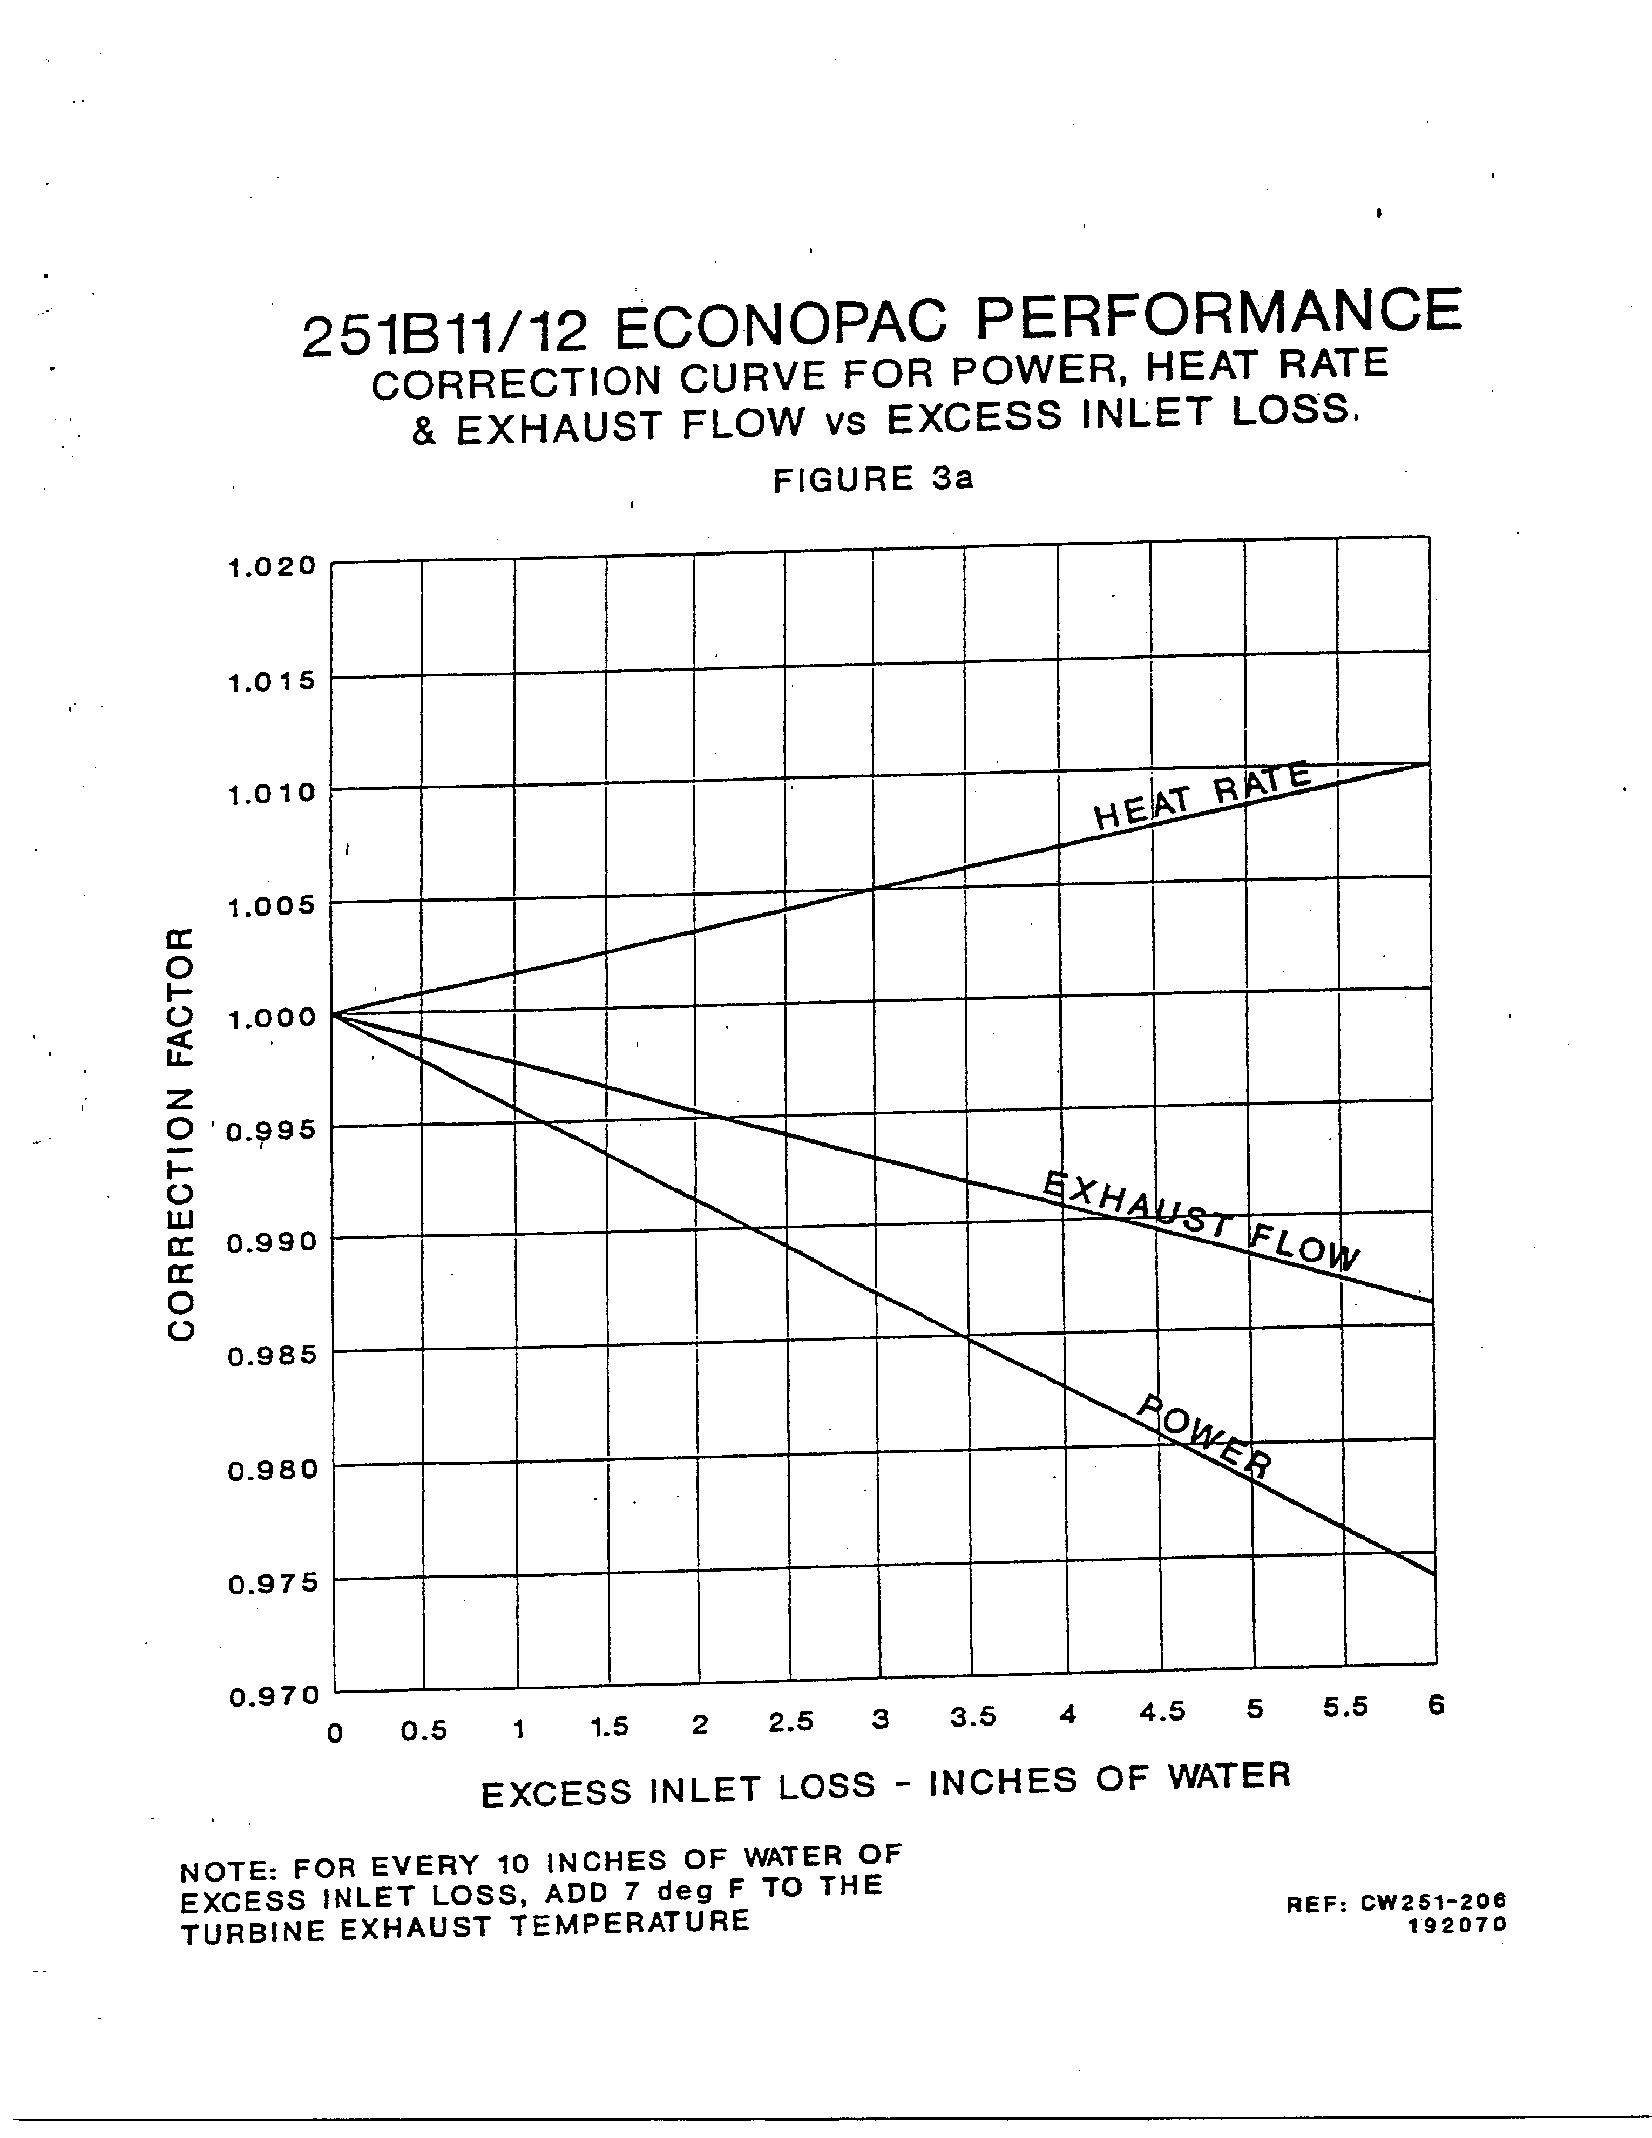

Figure : Correction curves for heat rate, exhaust flow, and power for inlet

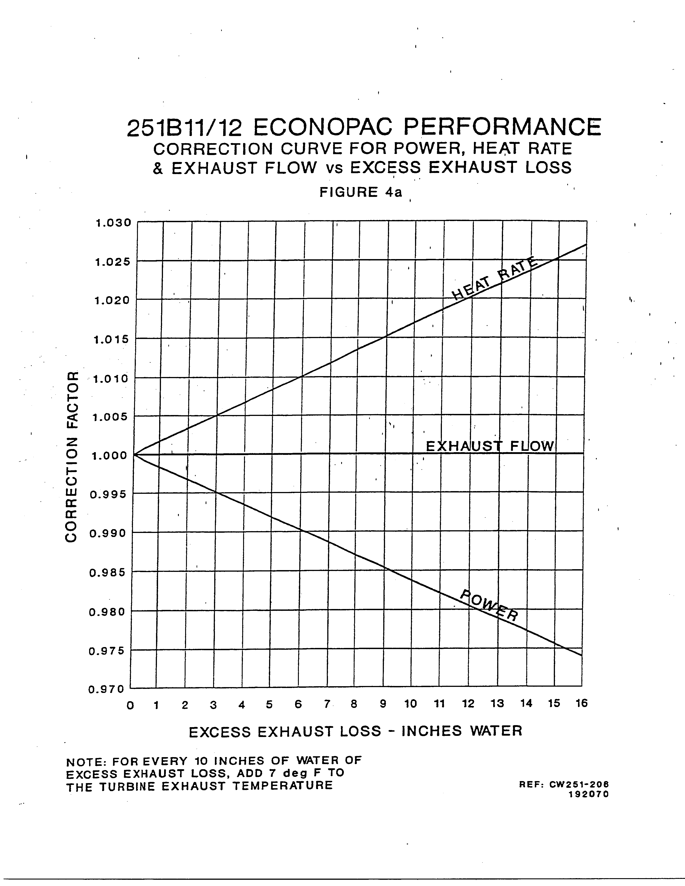

Figure : Correction curve for power, heat rate, and exhaust flow for exhaust

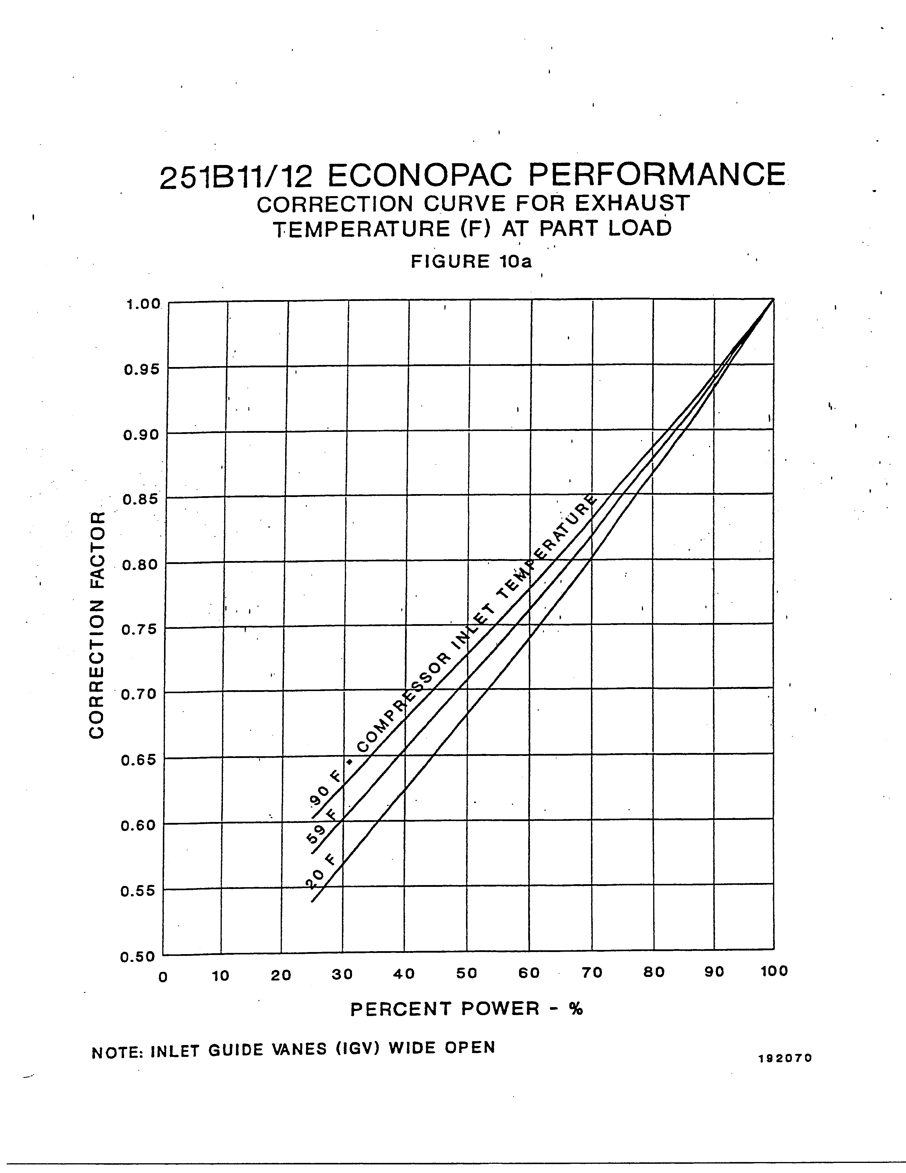

Figure : Correction curve for exhaust temperature at part load

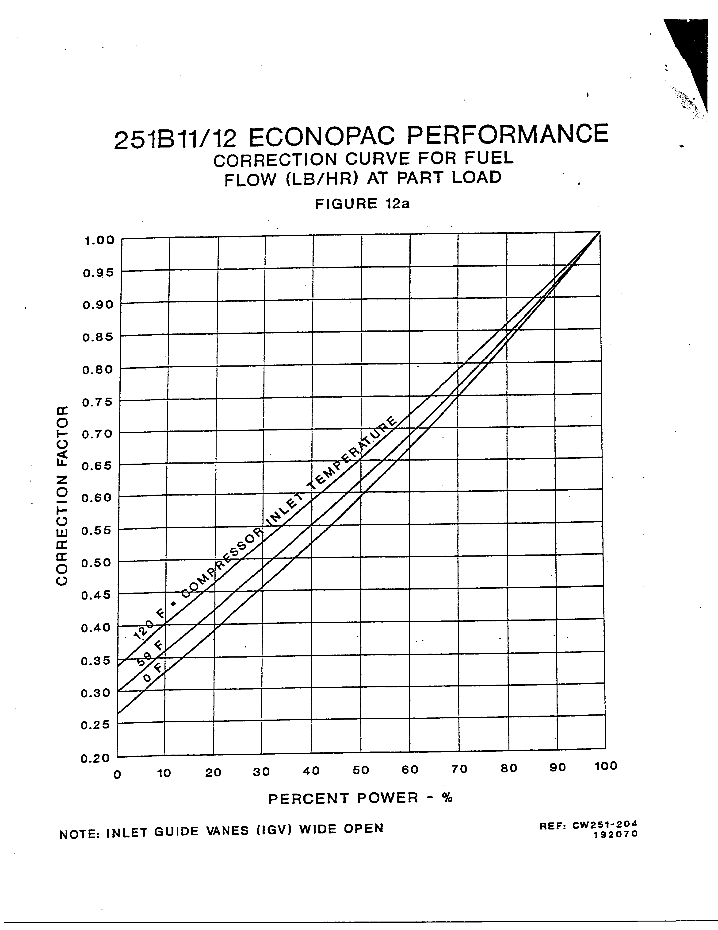

Figure : Correction curve for fuel flow at part load

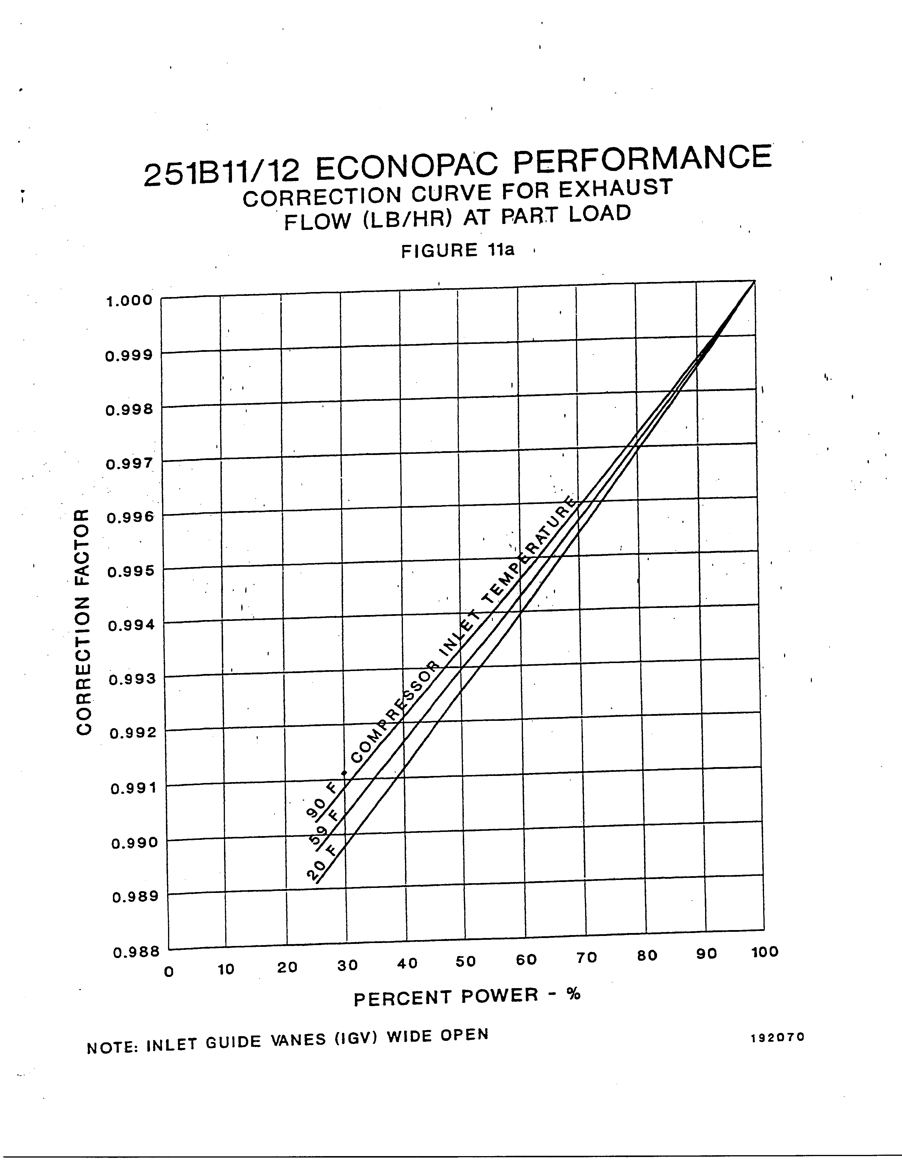

Figure : Correction curve for exhaust flow at part load

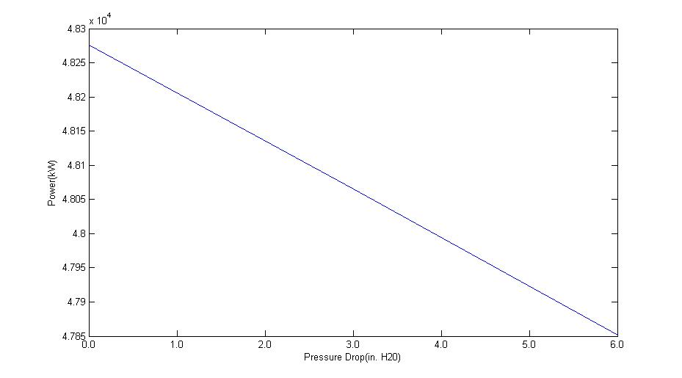

Figure : Curve of power versus pressure drop at the inlet

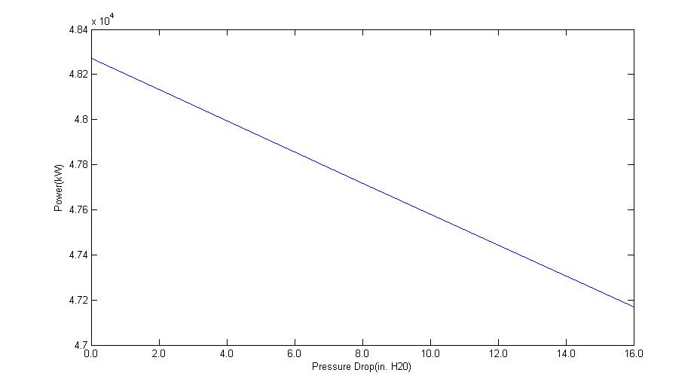

Figure : Curve of power versus pressure drop at the exhaust

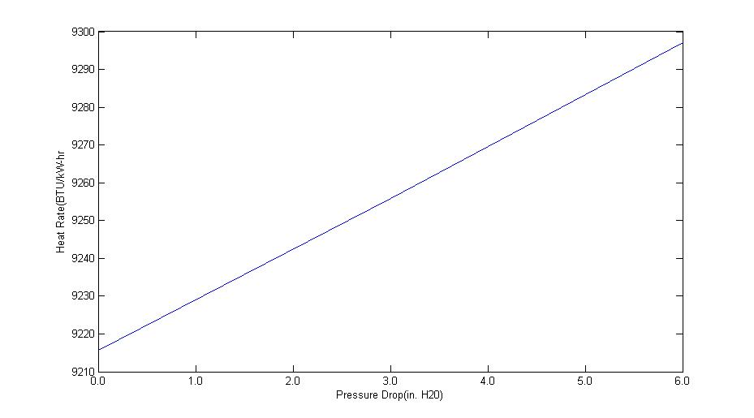

Figure : Curve of heat rate versus pressure drop at the inlet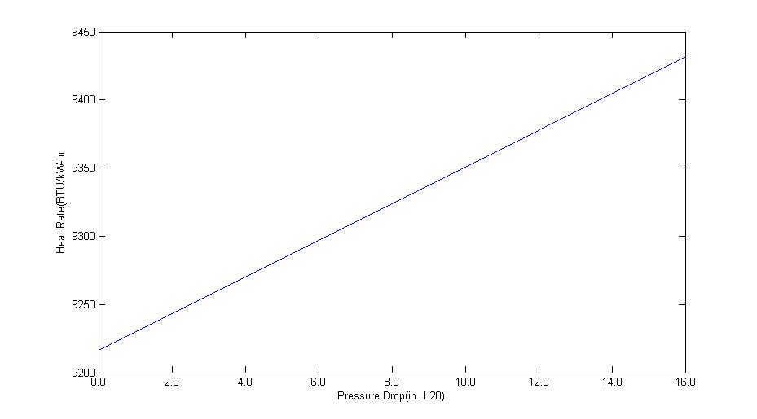

Figure : Curve of heat rate versus pressure drop at the exhaust

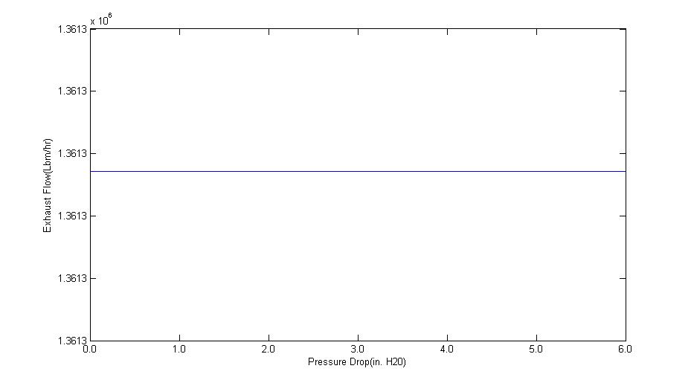

Figure : Curve of exhaust flow versus pressure drop at the inlet

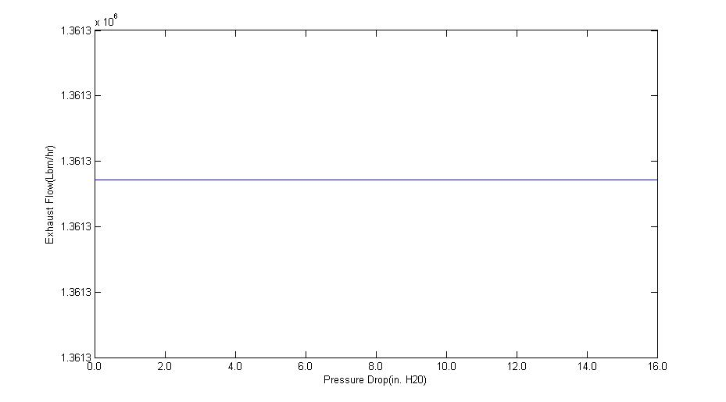

Figure : Curve of exhaust flow versus pressure drop at the exhaust

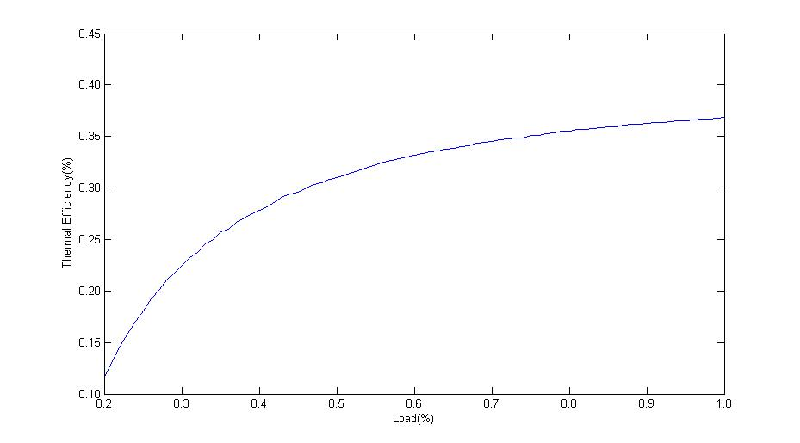

Figure : Curve of thermal efficiency versus percent load for the base case

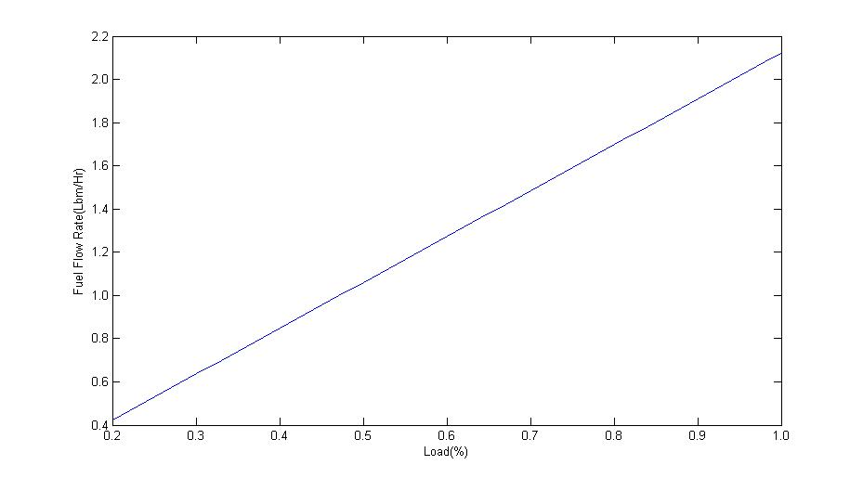

Figure : Curve of fuel flow rate versus percent load for the base case

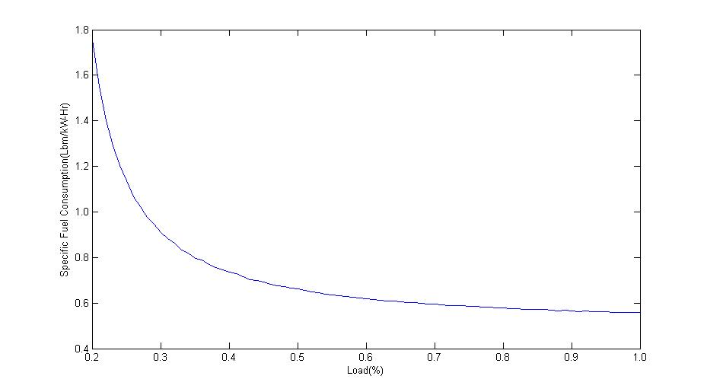

Figure : Curve of specific fuel consumption versus percent load for the base case

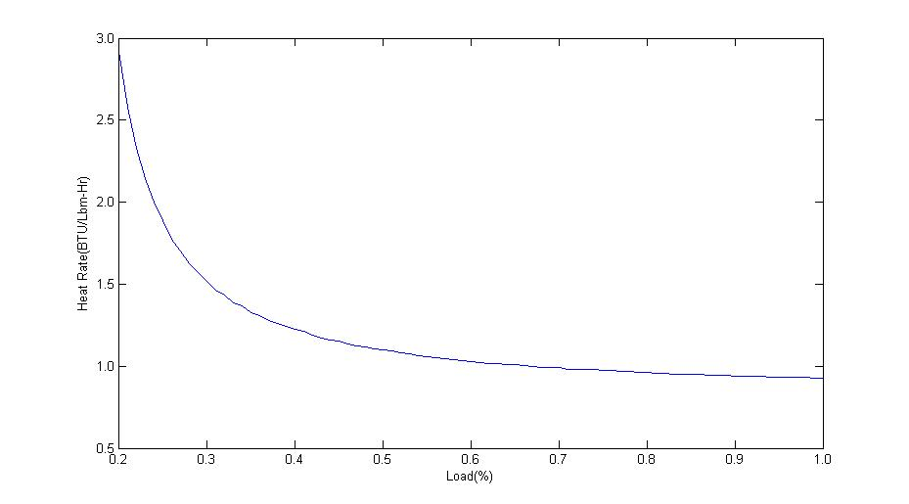

Figure : Curve of heat rate versus percent load for the base case

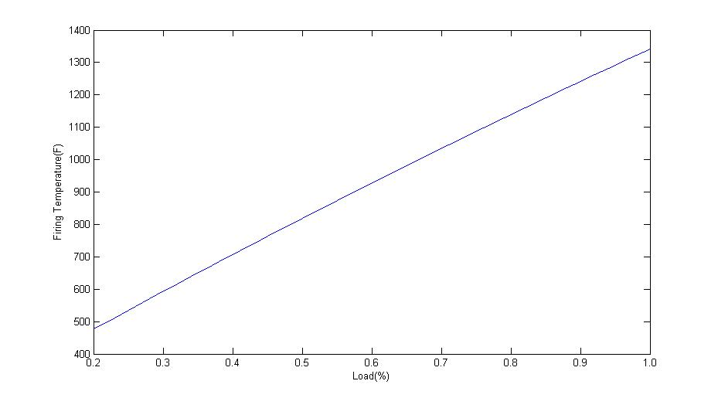

Figure : Curve of firing temperature (°F) versus percent load for the base case

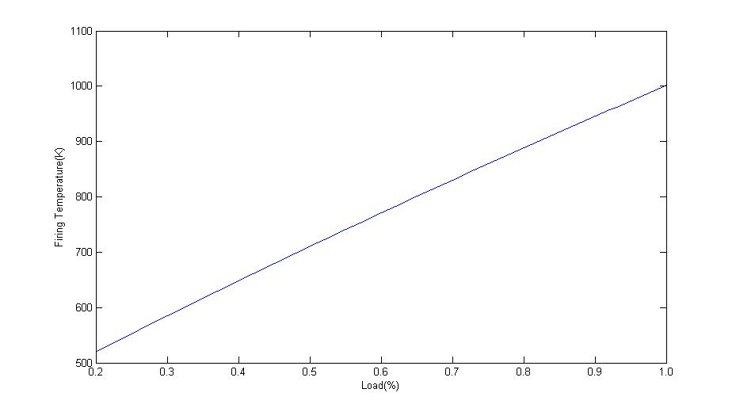

Figure : Curve of firing temperature (K) versus percent load for the base case

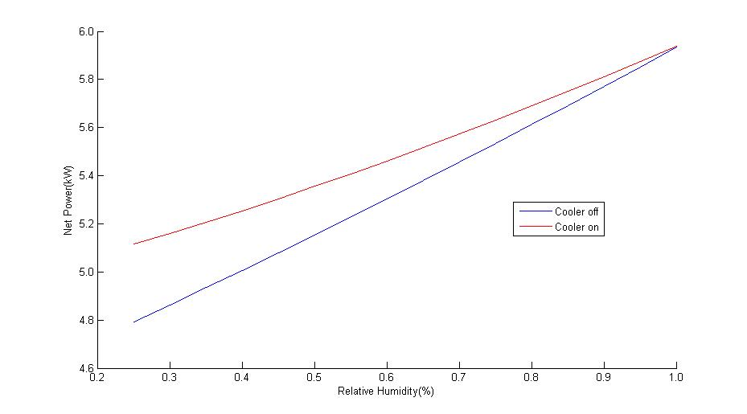

Figure : Curve of net power versus relative humidity for both cooler-on and cooler-off cases

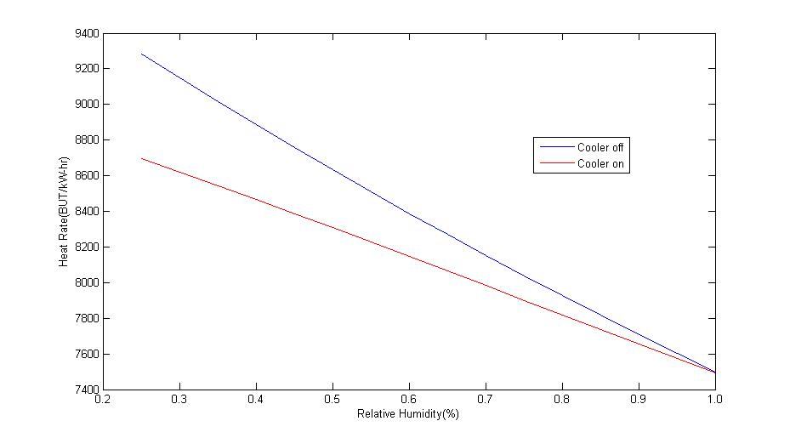

Figure : Curve of heat rate versus relative humidity for both cooler-on and cooler-off cases

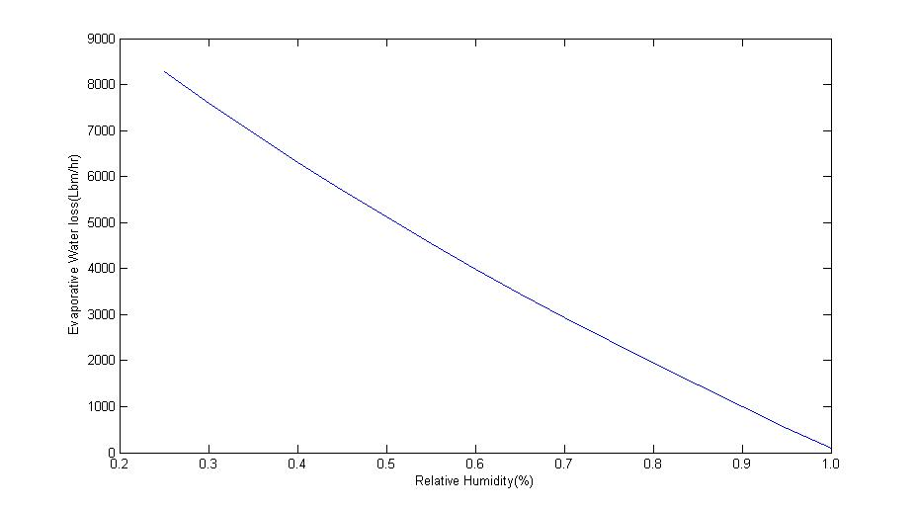

Figure : Curve of evaporative water loss versus relative humidity for the cooler-on case

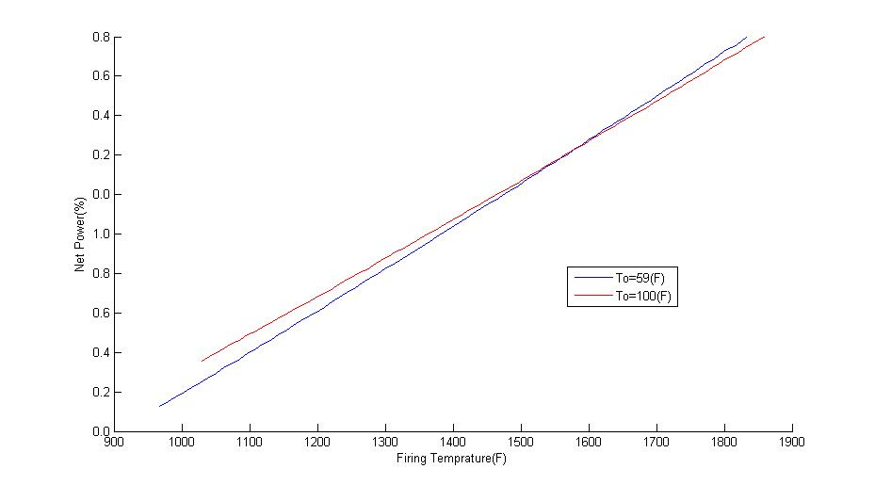

Figure : Curve of net power versus firing temperature

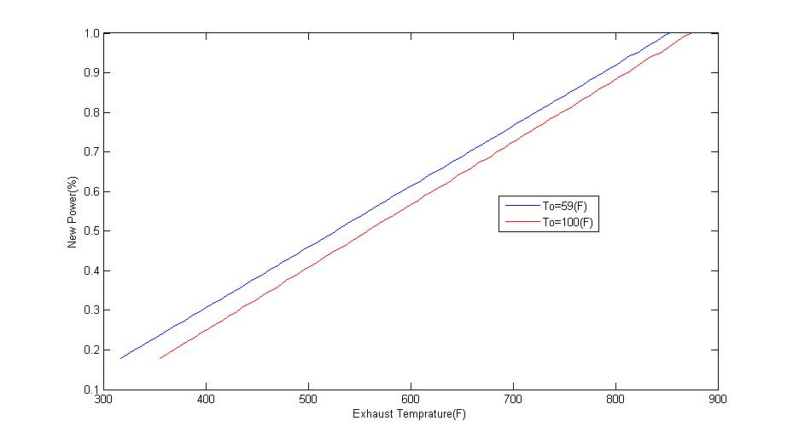

Figure : Curver of net power versus exhaust temperature

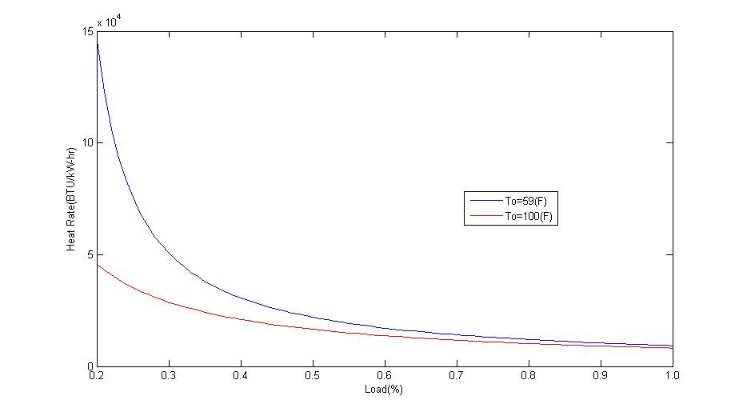

Figure : Curve of heat rate versus firing temperature

Figures for Property Calculator

CpvsTable.tif

Figure : Plot of Cp versus temperature for air composition of 79% N2 and 21% O2

CpvsTable1.tif

Figure : Plot of Cp versus temperature for accurate air composition values

Tables

Table : Computed versus Manufacturer's Quoted Performance

|  |  |  |  |
| --- | --- | --- | --- |
|  | Computed Performance | Manufacturer's Quoted Performance | Error |
| Net Power (MW) | 48 | 48 | 0.0000% |
| Heat Rate (Btu/kWhr) | 9,268.493 | 10600 | 12.5614% |
| Exhaust Flow (kg/hr) | 617,468.828 | 622170 | 0.7556% |
| Fuel Flow (lbm/hr) | 21,225.554 | 24280 | 12.5801% |
| Exhaust Temperature (°C) | 456.591 | 523 | 12.6977% |

Table : Inlet pressure drop versus power heat rate and exhaust flow

|  |  |  |  |
| --- | --- | --- | --- |
| Inlet Pressure Drop  (inches of H2O) | Power  (MW) | Heat Rate  (Btu/kWhr) | Exhaust Flow  (lbm/hr) |
| 0.0 | 48.27569 | 9215.561 | 1361293 |
| 3.0 | 48.0651 | 9255.939 | 1361293 |
| 6.0 | 47.8519 | 9297.178 | 1361293 |

Table : Exhaust pressure drop versus power heat rate and exhaust flow

|  |  |  |  |
| --- | --- | --- | --- |
| Exhaust Pressure Drop  (inches of H2O) | Power  (MW) | Heat Rate  (Btu/kWhr) | Exhaust Flow  (lbm/hr) |
| 0.0 | 48.27314 | 9216.048 | 1361293 |
| 8.0 | 47.71654 | 9323.551 | 1361293 |
| 16.0 | 47.16979 | 9431.622 | 1361293 |

Table : Correction factors for inlet pressure drop

|  |  |  |  |
| --- | --- | --- | --- |
| Inlet Pressure Drop  (inches of H2O) | Power  (MW) | Heat Rate  (Btu/kWhr) | Exhaust Flow  (lbm/hr) |
| 0.0 | 1.000 | 1.000 | 1.000 |
| 3.0 | 0.987 | 1.005 | 0.993 |
| 6.0 | 0.975 | 1.010 | 0.987 |

Table : Correction factors for exhaust pressure drop

|  |  |  |  |
| --- | --- | --- | --- |
| Exhaust Pressure Drop  (inches of H2O) | Power | Heat Rate | Exhaust Flow |
| 0.0 | 1.000 | 1.000 | 1.000 |
| 8.0 | 0.987 | 1.013 | 1.000 |
| 16.0 | 0.974 | 1.027 | 1.000 |

Table : Temperature at each major thermodynamic station

|  |  |  |  |  |  |  |  |  |  |
| --- | --- | --- | --- | --- | --- | --- | --- | --- | --- |
| % Load of Fuel Flow | | | | | | | | | |
| State | 1 | 0.9 | 0.8 | 0.7 | 0.6 | 0.5 | 0.4 | 0.3 | 0.2 |
| 0 | 288.00 | 288.00 | 288.00 | 288.00 | 288.00 | 288.00 | 288.00 | 288.00 | 288.00 |
| 1 | 288.00 | 288.00 | 288.00 | 288.00 | 288.00 | 288.00 | 288.00 | 288.00 | 288.00 |
| 2 | 288.00 | 288.00 | 288.00 | 288.00 | 288.00 | 288.00 | 288.00 | 288.00 | 288.00 |
| 3 | 659.04 | 659.04 | 659.04 | 659.04 | 659.04 | 659.04 | 659.04 | 659.04 | 659.04 |
| 4 | 1274.35 | 1218.56 | 1161.64 | 1103.54 | 1044.21 | 983.58 | 921.60 | 858.20 | 793.35 |
| 5 | 729.59 | 693.49 | 657.37 | 620.69 | 583.12 | 546.37 | 508.43 | 470.16 | 431.58 |

Table : Pressure at each major thermodynamic station

|  |  |  |  |  |  |  |  |  |  |
| --- | --- | --- | --- | --- | --- | --- | --- | --- | --- |
| % Load of Fuel Flow | | | | | | | | | |
| State | 1 | 0.9 | 0.8 | 0.7 | 0.6 | 0.5 | 0.4 | 0.3 | 0.2 |
| 0 | 101.32 | 101.32 | 101.32 | 101.32 | 101.32 | 101.32 | 101.32 | 101.32 | 101.32 |
| 1 | 100.33 | 100.33 | 100.33 | 100.33 | 100.33 | 100.33 | 100.33 | 100.33 | 100.33 |
| 2 | 100.33 | 100.33 | 100.33 | 100.33 | 100.33 | 100.33 | 100.33 | 100.33 | 100.33 |
| 3 | 1504.96 | 1504.96 | 1504.96 | 1504.96 | 1504.96 | 1504.96 | 1504.96 | 1504.96 | 1504.96 |
| 4 | 1504.96 | 1504.96 | 1504.96 | 1504.96 | 1504.96 | 1504.96 | 1504.96 | 1504.96 | 1504.96 |
| 5 | 102.32 | 102.32 | 102.32 | 102.32 | 102.32 | 102.32 | 102.32 | 102.32 | 102.32 |
| 6 | 101.32 | 101.32 | 101.32 | 101.32 | 101.32 | 101.32 | 101.32 | 101.32 | 101.32 |